**WEEK - 2**

**Logging Exercises**

**Mandatory**

**Exercise 1: Logging Error Messages and Warning Levels**

package com.example;

import org.slf4j.Logger;

import org.slf4j.LoggerFactory;

public class LoggingExample {

// Obtain a logger instance for this class

private static final Logger logger = LoggerFactory.getLogger(LoggingExample.class);

public static void main(String[] args) {

logger.error("This is an error message.");

logger.warn("This is a warning message.");

logger.info("This is an informational message.");

logger.debug("This is a debug message.");

logger.trace("This is a trace message.");

}

}

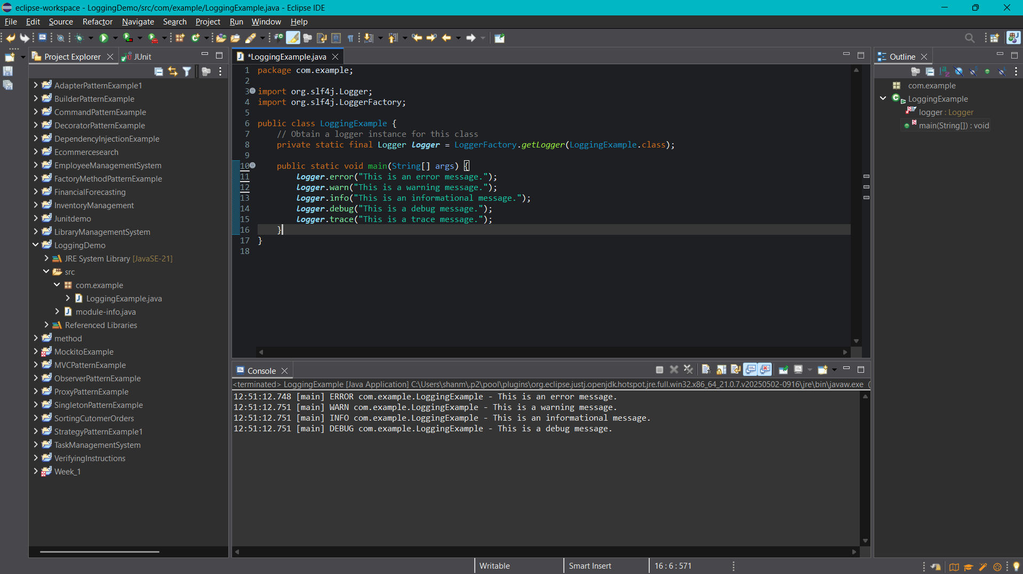

**Additional**

**Exercise 2: Parameterized Logging**

package com.example;

import org.slf4j.Logger;

import org.slf4j.LoggerFactory;

public class LoggingDemo {

private static final Logger logger = LoggerFactory.getLogger(LoggingDemo.class);

public static void main(String[] args) {

String username = "alice";

String operation = "login";

String time = "10:30 AM";

logger.info("User {} performed {} operation at {}", username, operation, time);

logger.warn("Disk space for user {} is running low", username);

logger.error("Error encountered while {} for user {}", operation, username);

}

}

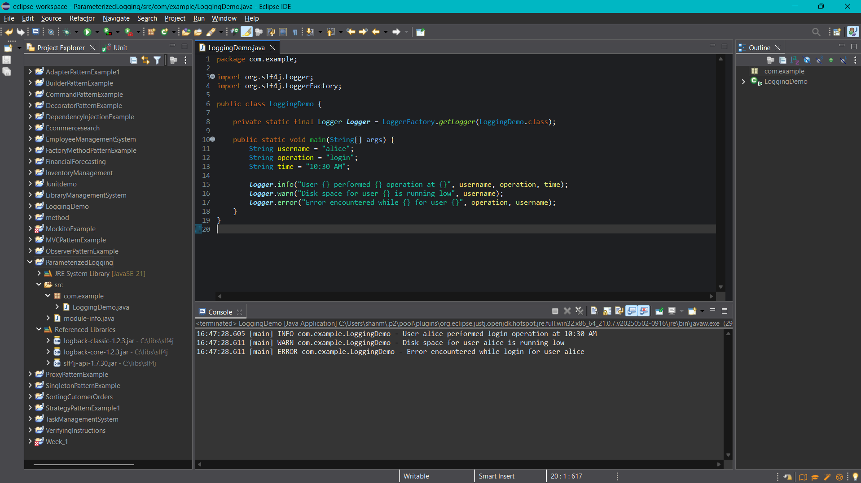

**Exercise 3: Using Different Appenders**

**Logback.xml**

<configuration>

<!-- Console Appender -->

<appender name="console" class="ch.qos.logback.core.ConsoleAppender">

<encoder>

<pattern>%d{HH:mm:ss.SSS} [%thread] %-5level %logger{36} - %msg%n</pattern>

</encoder>

</appender>

<!-- File Appender -->

<appender name="file" class="ch.qos.logback.core.FileAppender">

<file>app.log</file>

<append>true</append>

<encoder>

<pattern>%d{yyyy-MM-dd HH:mm:ss} %-5level %logger{36} - %msg%n</pattern>

</encoder>

</appender>

<!-- Root logger to use both appenders -->

<root level="debug">

<appender-ref ref="console" />

<appender-ref ref="file" />

</root>

</configuration>

**LoggingWithAppenders.java**

package com.example;

import org.slf4j.Logger;

import org.slf4j.LoggerFactory;

public class LoggingWithAppenders {

private static final Logger logger = LoggerFactory.getLogger(LoggingWithAppenders.class);

public static void main(String[] args) {

logger.debug("Debugging mode enabled");

logger.info("Application started");

logger.warn("Low memory warning");

logger.error("An unexpected error occurred");

}

}

